Day 28 – CI-Pipeline Assignment

Spring Boot Application CI Pipeline

1. Create a simple Spring Boot Application with an Endpoint

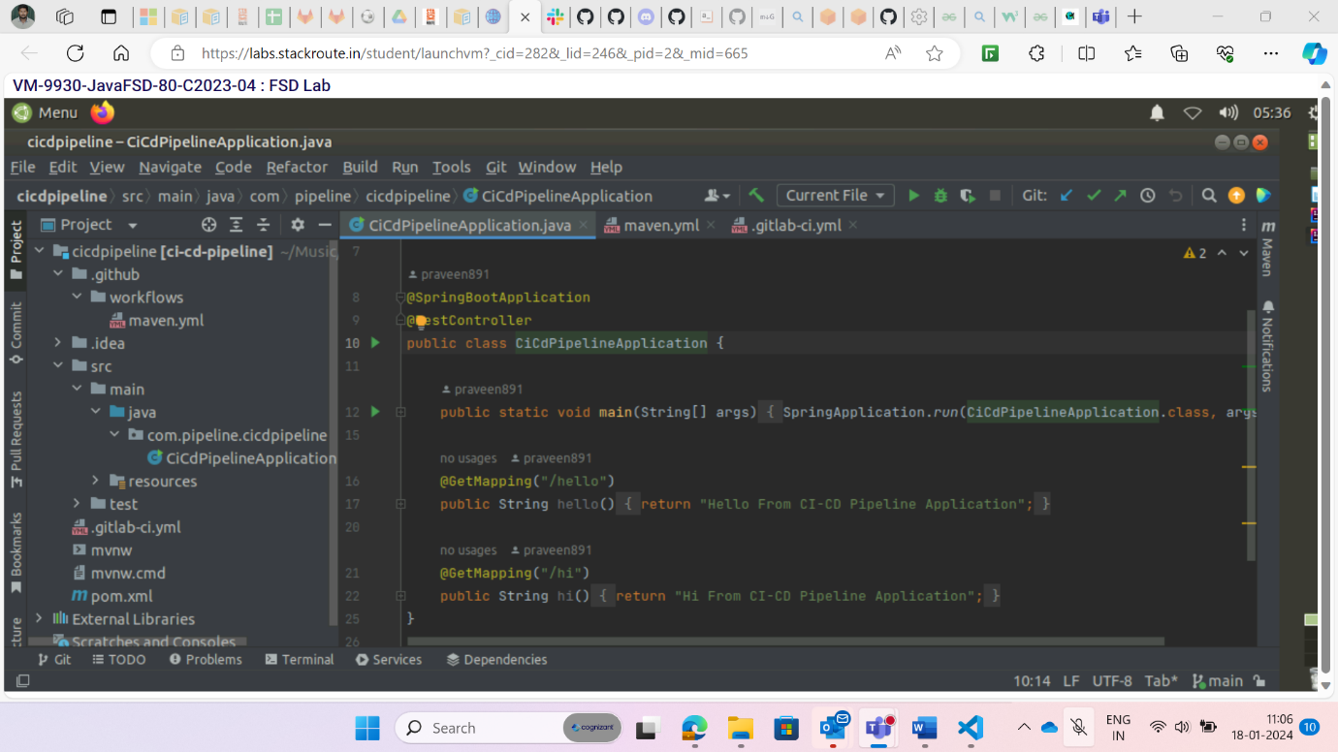

1. Create a github repository.

1. Create a Github Actions Workflows:

* In the root of your project, create a “.github/workflows” folder.
* Inside this folder, create a YAML file (maven.yml) for the Github Actions workflow.
* Configure the workflow to trigger on every push to the repository.

1. Save and Commit:

* Save the changes to the workflow file and commit them
* Observe the workflow execution on the Github Actions dashboard.

**GitLab CI**

1. Create a CI File:

* In the root of your project, create a “.gitlab-ci.yml” file.
* Configure the pipeline to trigger on every push to the repository.

1. Save and Commit:

* Save the changes to CI File and commit them into the repository.
* Monitor the pipeline execution in the Gitlab CI/CD dashboard.

